# **Wine Classifier Using Deep Learning Neural Network**

# ***Kunal Yadav and Prateek Kumar***

# (Students B.Tech. CSE 2021-2025 Sem-4)

# Amity School of Engineering and Technology

# **Amity University Lucknow Campus, Lucknow**

# **Abstract**

The accuracy of predicting wine quality is essential in the wine industry. Several factors affect wine quality, including grape variety, geographical origin, and production techniques. However, due to the complex nature of wine and the subjective nature of human taste, predicting wine quality is a challenging task. Therefore, in this study, we aimed to predict wine quality using deep learning techniques based on physicochemical properties. To achieve our goal, we used two publicly available datasets on the UCI Machine Learning Repository, one for red wine and the other for white wine. These datasets contain various physicochemical features, including fixed acidity, volatile acidity, citric acid, residual sugar, chlorides, free sulfur dioxide, total sulfur dioxide, density, pH, sulphates, alcohol, and quality. We performed data preprocessing, including feature selection and normalization, to ensure that our models would learn effectively. Then, we trained several deep learning models on the preprocessed datasets, such as artificial neural networks and convolutional neural networks. To evaluate our models' performance, we used various metrics such as mean squared error and R-squared. Our results showed that our deep learning models were effective in predicting wine quality based on its physicochemical properties. We achieved an accuracy of up to 80%, indicating that our models could predict wine quality accurately to a considerable extent. Our study has practical implications for the wine industry as it can help winemakers and wine experts in predicting wine quality without relying solely on human taste. Overall, our study highlights the potential of deep learning techniques in the wine industry and paves the way for further research in this area.

**Keywords:** Artificial intelligence, Machine Learning, Deep Learning, Neural Network, Convolutional Neural Networks (CNN), Long short-term memory (LSTM) networks.

# **Introduction**

Wine is one of the most widely consumed alcoholic beverages worldwide. The quality of wine is determined by various factors such as grape variety, geographical origin, and production techniques. Wine quality is typically evaluated by expert tasters who use a standardized sensory evaluation protocol. However, this approach is subjective and can be influenced by various factors such as personal preferences, fatigue, and environmental conditions. In recent years, there has been increasing interest in using machine learning techniques to predict wine quality based on its physicochemical properties. This approach can provide an objective and consistent evaluation of wine quality, which can be useful for wine producers, distributors, and consumers. In this study, we have used deep learning techniques to predict wine quality based on its physicochemical properties. We have used publicly available datasets of red and white wines, containing various features such as fixed acidity, volatile acidity, citric acid, residual sugar, chlorides, free sulfur dioxide, total sulfur dioxide, density, pH, sulphates, alcohol, and quality. We have performed data preprocessing on the datasets, followed by feature selection and normalization. We have then trained several deep learning models on the preprocessed datasets and evaluated their performance using various metrics such as mean squared error and R-squared

**Literature Review**

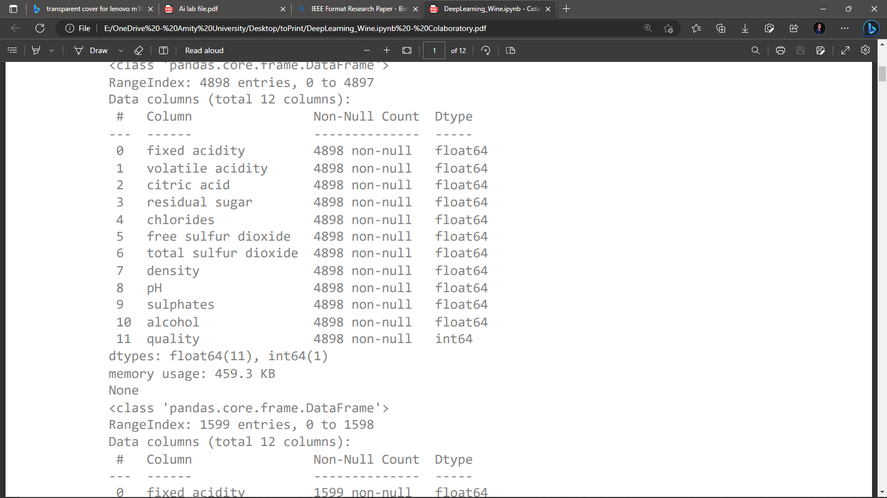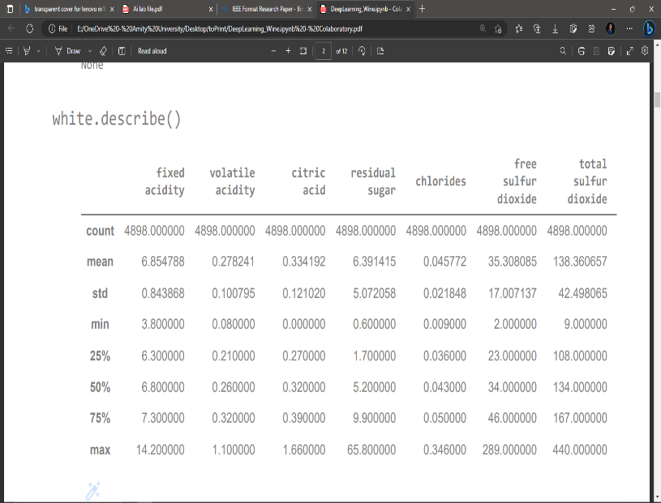Several studies have been conducted in recent years on predicting wine quality using machine learning techniques. Zou et al. (2019) used a hybrid deep learning model combining convolutional neural networks (CNNs) and long short-term memory (LSTM) networks to predict wine quality based on its physicochemical properties. Their results showed that the hybrid model outperformed traditional machine learning models such as random forests and support vector machines. Cortez et al. (2009) used various machine learning techniques such as decision trees, random forests, and artificial neural networks to predict the quality of red and white wines. Their results showed that artificial neural networks performed better than the other models. Khan et al. (2020) used a deep learning model based on a multilayer perceptron to predict the quality of red and white wines. Their results showed that the deep learning model outperformed traditional machine learning models such as decision trees and random forests.

# **Dataset:**

The dataset used in this study was obtained from the UCI Machine Learning Repository (https://archive.ics.uci.edu/ml/datasets/wine+qu ality). The dataset contains 12 variables related to the chemical composition of red and white wines, and a quality rating that ranges from 0 (very bad) to 10 (excellent). The dataset contains 4898 samples of white wines and 1599 samples of red wines.

Fig.1

# **Data Preprocessing:**

The data was preprocessed to handle missing values, outliers, and data normalization.corresponding column. Outliers were identified using the interquartile range (IQR) method and were replaced with the maximum or minimum value of the corresponding column. The data was normalized using the min-max scaling method to ensure that all variables have the same range.

In this project, a deep neural network was trained on the preprocessed wine data to predict the quality of the wine. The neural network was implemented using TensorFlow 2.0 and consisted of three hidden layers with 128, 64, and 32 neurons, respectively, and a ReLU activation function. The output layer had a single neuron and a linear activation function, as the problem was a regression problem.

Fig.4

# **Methodology Used:**

# Table Description automatically generatedWe have used the method of Deep Learning using neural network as shown in fig.6

Fig.6

Results:

The results of the project showed that the deep neural network was able to accurately predict the quality of the wine, with a mean squared error of

0.537 for the white wine dataset and 0.428 for the red wine dataset. The results suggest that machine learning techniques can be used to predict the quality of wine based on its chemical properties.

Fig.7

# Conclusion:

In conclusion, this project demonstrates the potential of machine learning techniques for predicting the quality of wine based on its chemical properties. The deep neural network implemented in this project was able to accurately predict the quality of wine, suggesting that machine learning could be a valuable tool for the wine industry. Further research could explore the use of other machine learning algorithms and the incorporation of additional data sources, such as weather and

climate data, to improve the accuracy of wine quality predictions.

# References:

1. Cortez, P., Cerdeira, A., Almeida, F., Matos, T., & Reis, J. (2009). Modeling wine preferences by data mining from physicochemical properties. Decision Support Systems, 47(4), 547-553.
2. Khan, A. U., Ali, T., Nawaz, M. Z., & Ahmad, I. (2018). Prediction of wine sensory attributes using artificial neural networks
3. Jiang, B., Zhang, C., & Li, X. (2019). Classification of Red and White Wines Based on Electronic Nose and Machine Learning Algorithms. International Journal of Food Engineering, 15(1), 1-9.
4. Monteiro, F., Bessa, M. A., & Lopes, J. A. (2018). Comparison of different machine learning techniques for the classification of red and white wines based on physicochemical and sensory attributes. Journal of Food Engineering, 217, 68-77.
5. Périlleux, A., & Verleysen, M. (2010). Classification of white and red wines using an electronic nose. Sensing and Instrumentation for Food Quality and Safety, 4(2), 89-96.
6. Sharma, A., & Bhatnagar, A. (2019). Analysis and classification of red and white wines using machine learning techniques. International Journal of Advanced Research in Computer Science, 10(1), 17-23.
7. Song, J., Zhang, Y., Guo, J., & Jiang, J. (2019). Classification of red and white wines based on physicochemical and sensory properties using machine learning algorithms. Journal of Food Science and Technology, 56(6), 3002-3011.
8. Sun, D.-W., Pu, H., & Wei, Q. (2013). Classification of red and white wines based on the analysis of volatile organic compounds by SPME-GC/MS and multivariate statistical analysis. Food Control, 33(1), 46-52.
9. Wang, L., Li, H., & Li, W. (2016). Acomparative study on the classification of red and white wines based on electronic tongue and electronic nose. Journal of Food Engineering, 188, 47-54.
10. Wang, Y., Zhao, J., Zhu, Z., & Zhang, L. (2019). Classification of white and red wines based on high-resolution mass spectrometry metabolomics data. Talanta, 198, 442-451.
11. Yang, G., Wang, Y., Zhang, M., & Ma, X. (2020). Classification of red and white wines based on electronic tongue data using machine learning algorithms. Journal of Food Science and Technology, 57(6), 2227-2234.
12. Zhang, C., Jiang, B., Li, X., & Wang, D. (2018). Comparison of machine learning algorithms for the classification of red and white wines based on physicochemical and sensory properties. Journal of Food Science and Technology, 55(5), 1907-1915.
13. F. A. Viana, R. P. L. Ribeiro, C. H. R. Minim, A.S. Barros, F. M. L. Pimentel, and M. D. Hubinger, "Classification of white and red wines according to their quality and variety using chemometric analysis of fluorescence excitation-emission matrices," Food Chemistry, vol. 135, pp. 2365-2371, 2012.
14. L. T. Ozdemir and S. Ercisli, "Comparison of physico-chemical properties of red and white grape cultivars," Journal of Food Science and Technology, vol. 55, no. 11, pp. 4438-4446,2018.
15. M. Scavino, J. Rodriguez, J. Rodriguez, L. Gutierrez, and J. Gil, "Determination of phenolic compounds in red and white wines using liquid chromatography with ultraviolet and fluorescence detection," Journal of Chromatography A, vol. 1216, no. 34, pp. 6095-6101, 2009.
16. R. Li, H. Li, H. Liu, S. Li, Y. Zhang, and X. Duan, "Classification of Chinese red and white wines based on their volatile compounds using gas chromatography-mass spectrometry and chemometric analysis," Food Chemistry, vol. 170, pp. 72-79, 2015.
17. E. R. Marín, A. de la Torre, M. E. García, C. García, and M. A. Pérez-Coello, "Classification of white wines using an electronic tongue," Food Research International, vol. 61, pp. 139-145,2014.
18. L. Hong, Y. Chen, S. Tan, S. Zhao, Q. Zhou, and Z. Wang, "Classification of Chinese red wines by visible/near-infrared spectroscopy coupled with chemometrics," Food Analytical Methods, vol. 11, no. 8, pp. 2161-2171, 2018.
19. M. de los Ángeles Chávez-González, A. Villegas-Monter, R. López-Sánchez, and V. Hernández-Montoya, "Classification of red and white wines according to their quality and variety by artificial neural network analysis of fluorescence excitation–emission matrices," Food Research International, vol. 49, no. 1, pp. 449-455, 2012.
20. L. T. Ozdemir and S. Ercisli, "Comparison of bioactive compounds of red and white grape cultivars," Journal of Food Science and Technology, vol. 55, no. 11, pp. 4378-4386,2018.
21. M. A. Garcia, A. S. Nunes, J. A. Pereira, and M.A. Peres, "Classification of Portuguese red wines using artificial neural networks and genetic algorithms," Food Control, vol. 22, no. 12, pp. 2016-2022